|  |  |  |  |  |  |  |
| --- | --- | --- | --- | --- | --- | --- |
| as | | | | | | |
| System Architecture Document | | | | | | |
| Assistant Referee Project | | | | | | |
|  | | | | | | |
| Date |  | Our reference |  | Version |  |  |
| February 5 2024 |  | ​ |  | 2 |  |  |
|  | | | | | | |

|  |
| --- |
| Mathematics and Computer Science |
| Mechatronic Systems Design EngD |
|  |
| T +31 (0)40 247 ​ |
|  |
| [www.tue.nl](http://www.tue.nl) |

Authors

MSD 2023

​

Client

René van de Molengraft, Erjen Lefeber

Copy to

​

Contents

1 ‎Introduction 3

1.1 Goal 3

1.1.1 Project Context 3

1.1.2 Previous Works 3

1.1.3 RoboCup Middle Size League (MSL) Rules 3

2 System Thinking Processes 4

2.1 Needs and Missions 4

2.2 Requirements and Use Cases 4

2.3 System Architectural Diagram 5

2.4 Validation 6

2.5 Risk Management 6

2.6 Feasibility Study 6

2.7 Development Approach 6

2.8 Work Breakdown Structure 6

References 8

An example of a section header 8

An example of a subsection header 8

An example of a section header 9

Example of a section header above a table 9

Appendix

​

# ‎Introduction

Starting from 2015, MSD EngD has been assigned to Autonomous Referee Project as the 1st in-house project. Most of the stakeholders’ needs remained the same, and MSD 2023 oversaw this project in 2024.

## Goal

The end-goal of the project is to create a fully autonomous referee for the RoboCup Middle Size League soccer match replacing human referee when sensing and making decision. Since all of the previous team have not been able to create a fully autonomous referee, the stakeholders’ minimum goal was to add something new or to improve the previous system. Therefore, the goal for this project is limited to assistant referee in which improvements can be made upon.

### Project Context

The developed system will be tested using Tech United soccer robots (TURTLE). It should be able to create logs and show evidence if needed. Furthermore, the project should be built on the earlier work and should have a structure to make it possible for future generations to work on. To achieve this, clear documentation including the earlier work process should be included. To avoid any misperception, the general expected systems (needs) were listed below:

* The AssistRef should be fast and accurate when making decisions.
* The system can communicate the decisions to teams, human referee, and viewers.
* It can be applied on RoboCup competition with at least using TURTLE and MSL field.
* A validation method should be presented and used.
* The system should have logs of the match and can show evidence of violations when needed.

Additionally, the stakeholders wants were:

* The project should build on the work of the previous years.
* Deliverables: presentation (include demonstration) and documentation.
* Personal goals of the team members should be achieved during the process.
* Proper documentation should be provided.

### Previous Works

The summary of the previous works has been documented in [Summary of Previous Batches (2015-2022)](https://github.com/KareemGhedan/MSD-AutoRef-2023/blob/main/General/Previous%20Years/Summary%20of%20Previous%20Batches.pdf). To understand what the previous works has achieved, it was much easier to read the provided document rather than looking back on their repositories.

### RoboCup Middle Size League (MSL) Rules

RoboCup MSL rules were quite complicated. This document used [2024 RoboCup MSL rulebook v25.0](https://tuenl-my.sharepoint.com/personal/j_w_tandio_tue_nl/Documents/Projects/AutoRef/Rulebook_MSL2024_v25.0.pdf). The general rule was to use *FIFA (Fédération Internationale de Football Association) rules*, but since the soccer game context had differences, the rules were modified into *RoboCup Changes and Comments*. In short, the order of the rules from the highest prioritized to lowest were the *Competition Laws*, *RoboCup Changes and Comments*, and *FIFA rules*. To simplify, an Excel file to summarize some of the rules has been made and it can be found [here](https://tuenl-my.sharepoint.com/:x:/g/personal/d_akyazi_tue_nl/EUf_Zbnrn_ZNo9V2R1uaFSoBA5OlvIPTQLuiyLAhFXnrOg?e=3zIqd2).

# System Design Processes

## Needs and Missions

Needs:

* Communicability (Capable to show proof, sending decisions)
* Objectivity (Fairness related, the system is impartial):
* Precision and Accuracy at least as good as human
* Robustness:
* Real-time (decision taken at the instant of the actual incident with minimal delay)
* Adaptability
* Need to follow RoboCup MSL Rules
* Safety

Mission:

* To observe the match and make autonomous, unbiased decisions based on the soccer robot rules that can be communicated to teams and viewers.

## Requirements and Use Cases

|  |  |  |  |
| --- | --- | --- | --- |
| **Super System** | **Human referee, Tech United, RoboCup teams, TURTLE, Audience, RefBox** | **Human referee, Tech United, RoboCup teams, TURTLE, Tech United field** | **Tech United, RoboCup teams, TURTLE, Refbox, Audience** |
| **System** | **Ball Out of Play, 0.5 meters free roll,**  **robot and ball positions (TURTLE), Replay moments** | **Corner Kick Rules (partial)** | **Autonomous referee** |
| **Sub-system** | **TURTLE’s Data, Tech United soccer field, MATLAB custom functions, Camera, Drone, Computer** | **Cameras, YOLOv5, bird’s eye transformation, Computer** | **Sensors, Actuation (communication protocols), Software (vision processing, decision-making module), Computer, Display Hardware** |
|  | **Past** | **Present** | **Future** |

New Functions àSub-systemàTechnical RequirementsßVerification

Functional requirements of the proposed AssistRef with its specification:

1. AssistRef can make combined decision (out of field and last touch) on real-time (when an event occured within 1 seconds).
   1. Reason: Based on discussion with Tech United and previous project requirement.
2. AssistRef can distinguish which team touched the ball the last time when the whole ball is out of field with desired accuracy at least as good as human, 70% correct decision.
   1. Reason: Since AssistRef needs to help the referee, it must be at least as good as human.
   2. Reference: ([55% to 85% accurate on average for a match](https://tomkinstimes.com/2018/03/how-accurate-are-referees-the-pr-v-the-research/), [Brazilian referees by De Oliveira et all (2011)](https://www.semanticscholar.org/paper/Call-Accuracy-and-Distance-from-the-Play%3A-A-Study-Oliveira-Orbetelli/45ec358f556d9ab1b1b65e8d2a2a10202a789d80?p2df), Physical Performance and Decision Making in Association Football Referees: A Naturalistic Study)
3. AssistRef must have at max distance error between ball and line of ±1.5 cm.
   1. Reason: Since the RoboCup rule is based on FIFA, the acceptance accuracy from FIFA using Goal-Line Technology was ±1.5 cm.
   2. Reference: Goal-Line Technology testing manual 2020
4. AssistRef must ensure operational time of 2 hours.
   1. Reason: Based on Goal-Line Technology which has safety factor of 4 (6 hours operational time with 1.5 hours playing time) and RoboCup MSL playing time of 0.5 hour, the required operational time was 4*0.5 = 2 hours
5. AssistRef must receive data from independent sensor (not from any sensor in competing team robots)
   1. Reason: To avoid any bias in decision making.
6. AssistRef must be able to communicate its decision process when needed.
   1. Reason: For transparency purpose (necessary article to be used as proof), and improvement in better algorithm

## Significant Architectural Decision Registers

* Main programming language: MATLAB
  + Reason: straightforward to develop, integrate, and implement.
* Modularize every component in the system
  + Reason: to make it reusable, for better readability, and simple validation
* Sensor system is based on OptiTrack
  + Reason: explained in Feasibility Study
* Main purpose of system: to make decision which team touch the ball the last time when the ball is out of field
  + Reason: challenging decision based on RoboCup referee
* Sensor System takes data from gameplay/match
  + Reason: to make unbiased decisions
* Any logs are created locally
  + Reason: creating logs in cloud is hard and this is not crucial

## System Architectural Diagram

System Context Diagram:

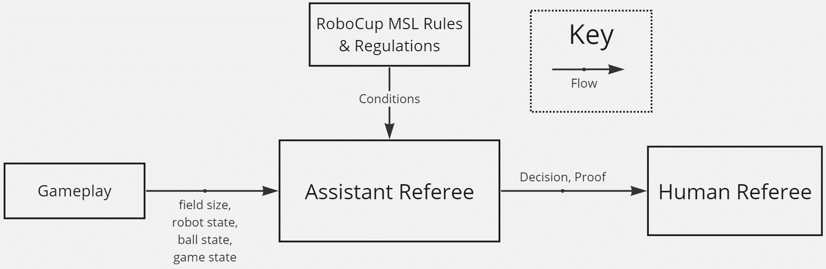

System Operational Diagram:

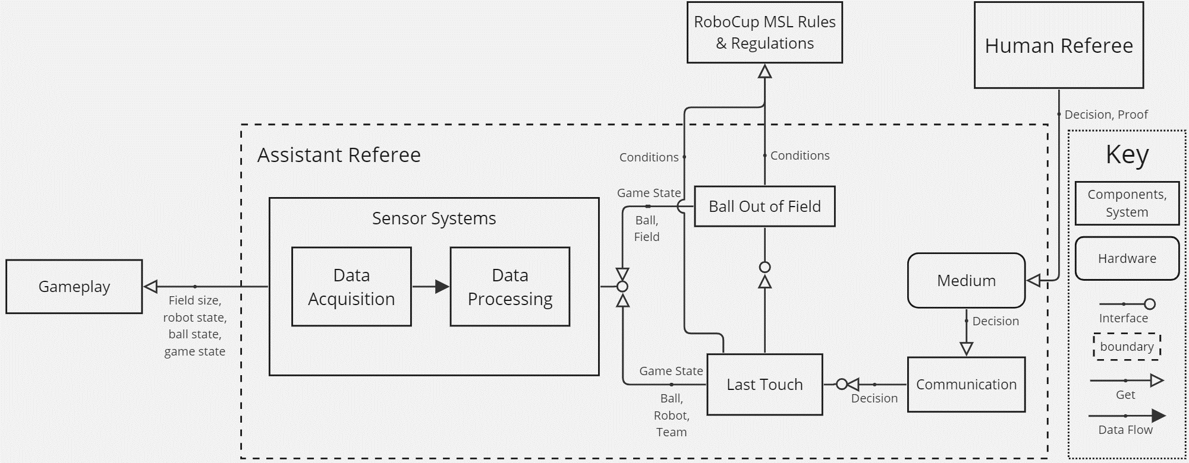

## Validation

The validation method was described in the [validation document](https://github.com/KareemGhedan/MSD-AutoRef-2023/blob/main/Deliverables/Validation%20Methods.docx). In this section, the system setup, testing procedure, statistical methods, and ground truth will be explained. The purpose of this document was to measure if the proposed system achieves the desired target.

## Risk Management

The risks of the defined architecture were listed in the [registers](https://github.com/KareemGhedan/MSD-AutoRef-2023/blob/main/Registers/Registers.xlsx), and its detail can be referred in the Project Management Plan document.

## Feasibility Study

The feasibility study has been documented in the [feasibility document](https://tuenl-my.sharepoint.com/:w:/g/personal/j_w_tandio_tue_nl/EQn8xFBj76ZLq-_pd0UQg2oB1M4lCCi3ijY_NO7Bfm-KLQ?e=4uueP4). As a summary, the chosen sensor was OptiTrack. More explanation can be found in the documentation.

## Development Approach

The development approach for the Assistant Referee is divided into 4 parts: the sensor system, ball out of field function, last touch function, and communication system.

The sensor system used OptiTrack to acquire position data of the ball centre and the robot top position. These data were broadcasted. Data were filtered to remove the noisy data caused by disturbances such as lighting conditions and bad markers.

The ball out of play check if the filtered data is inside the 4 corner points of the field. It would output binary decision, which will be used to show which robot touch the ball the last time.

The last touch function used random forest classifier to determine if a robot touch the ball or not. Data were gathered by recording non-touch data and touch data with cases if the ball is in the air or in the ground. Data is pre-processed and the features were the relative distance of the ball with the robot. These data were divided into training, validation, and test sets. The hyperparameters were adjusted to give the best f1 score.

The communication system use simple UI to communicate the decision to the referee and received input of the game state from the referee. All the functions are integrated to a state machine, which was shown below:

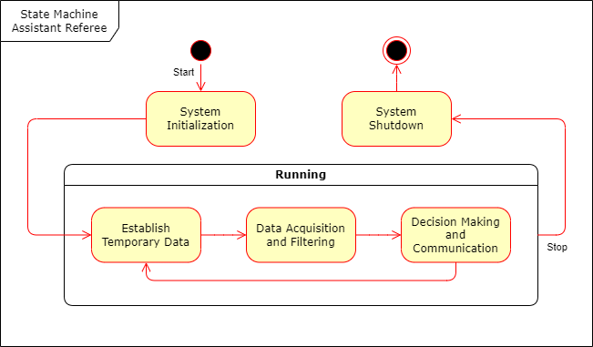

First the system initialized constant parameters and import all necessary modules. Then it established temporary data to store all the intermediate decisions and previous data. Next the system acquired data and perform data filtering if needed. After receiving the data, the system made its decision with the chosen algorithm and communicated it to the referee via a monitor with simple UI.

## Solution Breakdown Structure

Proposed Assistant Referee (AssistRef) for RoboCup competition:

* Decide which team is the last one to touch the ball at the current time.
  + Reason: Challenging in terms of implementation with accuracy better than human, can change game outcomes, request by referee (Danny Hameeteman) to avoid subjectivity
* Decide if the ball is out of field.
  + Reason: Common occurrences in match, for better implementation of the last touch function
* Communicate the decision to referee.
  + Reason: To give more information from the AssistRef to referee for better judgement.

Acknowledgement

Many thanks to:

* René van de Molengraft and Erjen Lefeber [stakeholders] – guidance
* Ruben Beumer [Tech United] – technical requirements and equipments
* Aykut Işleyen [Tech United] – OptiTracks
* Danny Hameeteman [RoboCup Referee] - technical requirements
* Sander Doodeman [Tech United] – OptiTracks
* André Rozendaal and Coby Doreleijers [PD Coaches] – feedbacks